1 Walkthrough 37 Content Density

https://sapui5.hana.ondemand.com/#/topic/d935dbf196d34997bf1ac42ac3e81579



2 Core Changed Codes Compared to Last Version:

2.1 Component.js 根据是否支持触屏获得内容紧凑程度的样式ID

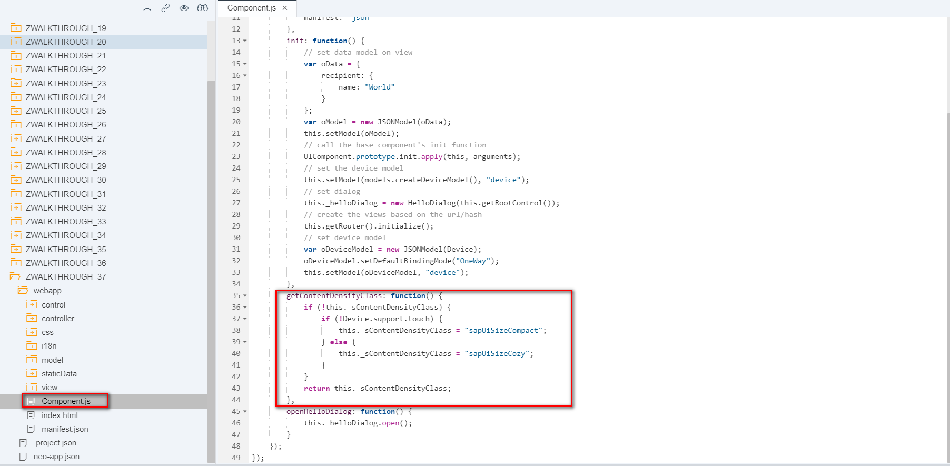

2.2 App.controller.js 为应用添加内容紧凑度样式

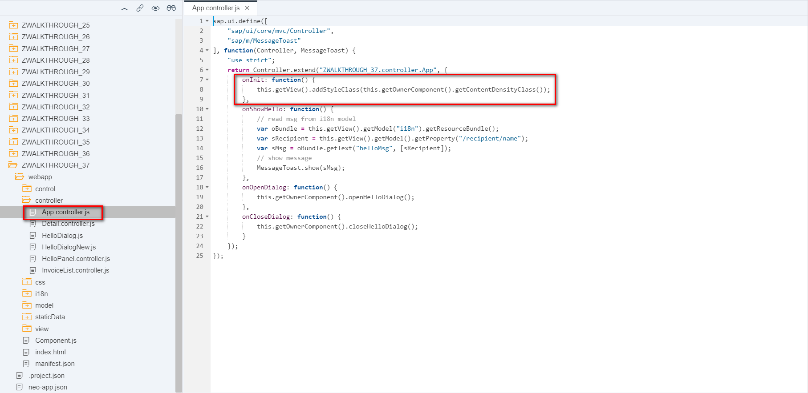

2.3 HelloDialog.js 为对话框增减内容紧凑度样式

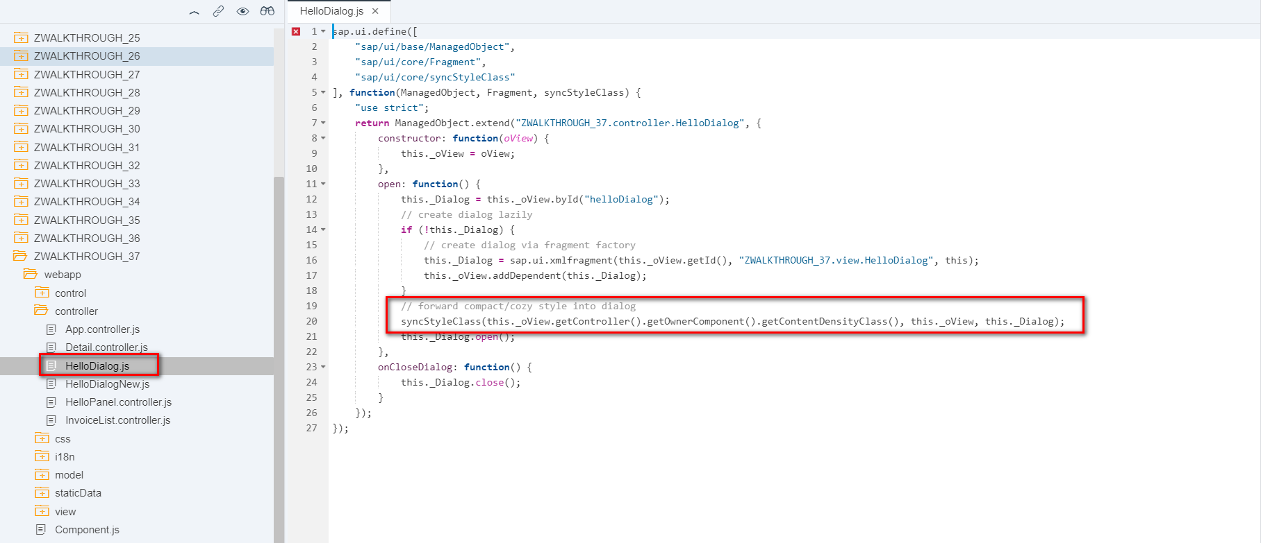

2.4 HelloPanel.controller.js为对话框增减内容紧凑度样式

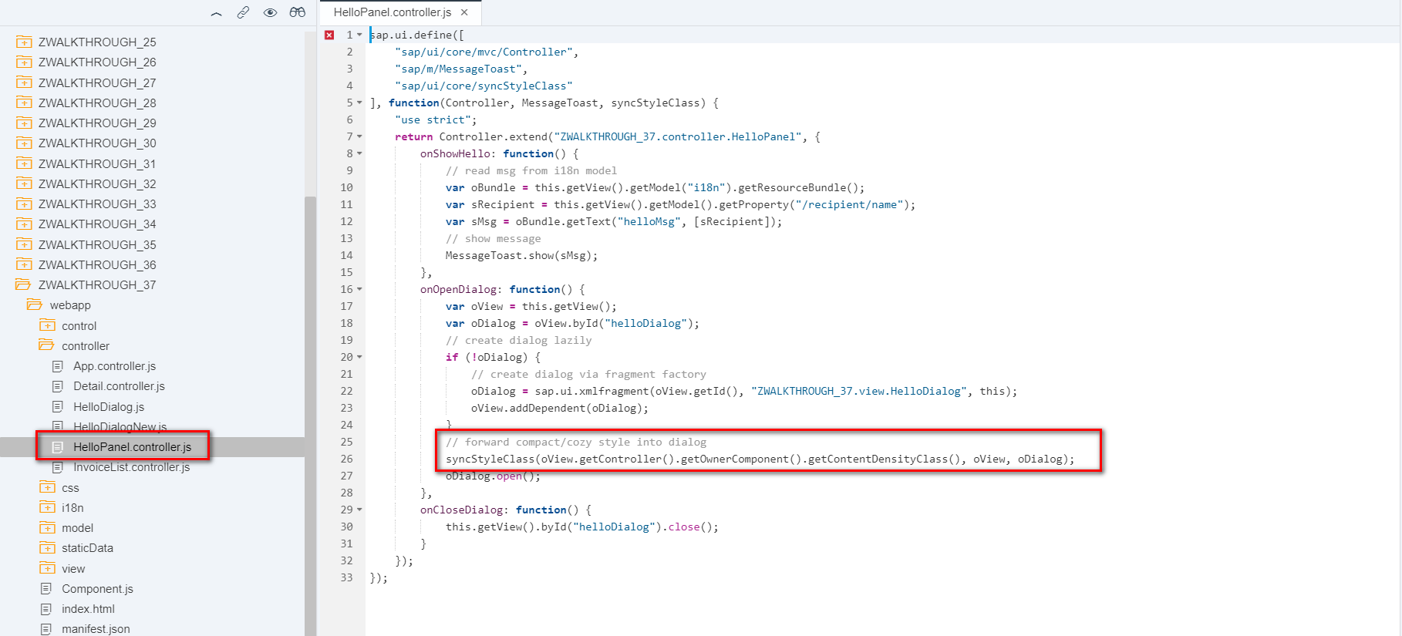

2.5 manifest.json 内容紧凑相关主数据

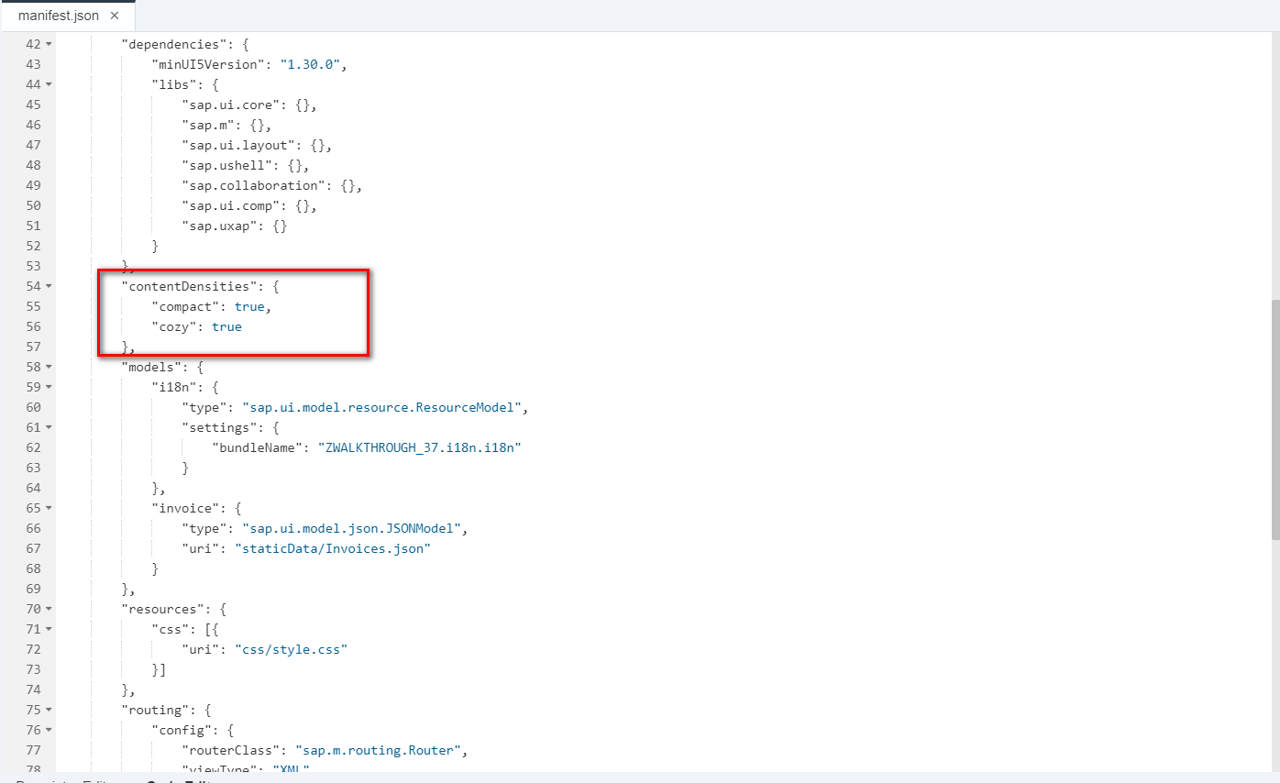

2.5 i18n 统一文本对象管理

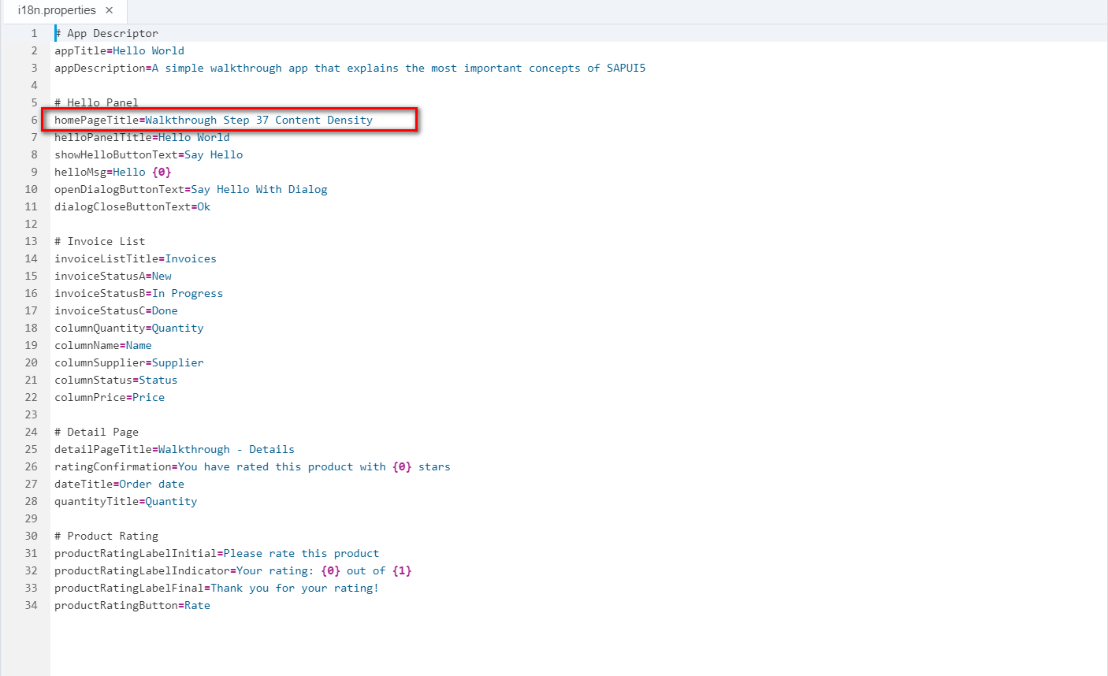

3 Result

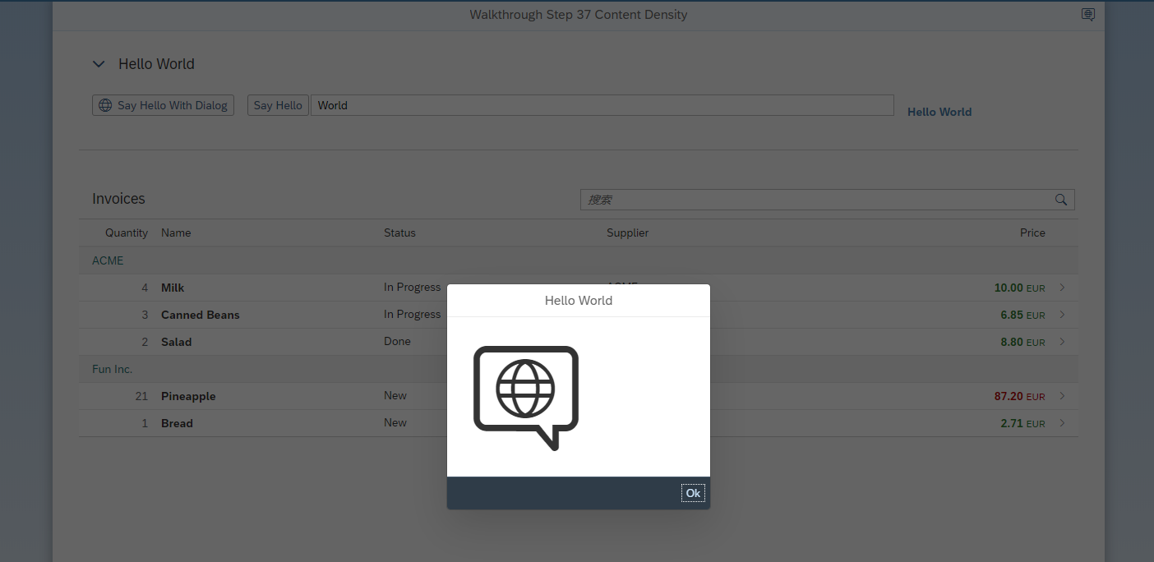

4 Git:

https://github.com/xiexiaop/SAPUI5-2-Round/tree/master/Projects/ZWALKTHROUGH_37

2019/02/08 XiaoMi Beijing Zac,Xie